**The Effect of Indwelling Arterial Catheters in Hemodynamically Stable Patients With Respiratory Failure: A Propensity Score Analysis**

Douglas J. Hsu, MD* (1, 2), Mengling Feng, PhD* (3, 5), Rishi Kothari, MD (4), Hufeng Zhou, PhD (6), Leo A. Celi, MD MS MPH (1, 3)

1. Division of Pulmonary, Critical Care, and Sleep Medicine, Beth Israel Deaconess Medical Center, Boston, MA
2. Division of Pulmonary and Critical Care Medicine, Massachusetts General Hospital, Boston, MA
3. Laboratory of Computational Physiology, Massachusetts Institute of Technology, Cambridge, MA
4. Department of Anesthesia, Mount Sinai Hospital, New York, NY
5. Institute for Infocomm Research, Singapore
6. Department of Medicine, Brigham and Women's Hospital, and Department of Microbiology and Immunobiology, Harvard University, Cambridge, MA.

* These authors contributed equally in this work.

**Corresponding Author**

Douglas Hsu, MD

Bullfinch 148

55 Fruit Street

Boston, MA 02214

[dhsu@bidmc.harvard.edu](mailto:dhsu@bidmc.harvard.edu)

(617) 667-5864

(888) 314-5895

**Author Contributions:**

Conception and Design: DH, LC, MF

Analysis, Data collection, and Interpretation: DH, MF, RK, HZ, LC

Drafting Manuscript: DH, MF, RK, HZ, LC

**Sources of Support:**  National Institute of Biomedical Imaging and Bioengineering grant R01 EB001659. Dr. Feng’s fellowship is supported by A*STAR Graduate Scholarship.

**Word Count:** 2099

**ABSTRACT**

**Rationale:** Indwelling arterial catheters (IACs) are used extensively in the Intensive Care Unit (ICU) for continuous hemodynamic monitoring and for arterial blood gas analysis. The use of IACs in the ICU setting is widespread, occurring in approximately 30% of ICU patients. IACs pose potentially serious risks, including blood stream infections and vascular complications.

**Objectives:** The purpose of this study is to assess whether the presence of IACs improves outcomes in mechanically ventilated patients who do not require vasopressor support.

**Methods:** This study utilized the Multiparameter Intelligent Monitoring in Intensive Care II (MIMIC-II) database, a publicly available database of over 32,000 patients admitted to the Beth Israel Deaconess Medical Center ICU between 2001 and 2008. Patients who required mechanical ventilation who did not require vasopressors or have a diagnosis of sepsis were identified, and the primary outcome was 28-day mortality. We developed a model based on patient demographics, co-morbidities, vital signs, and laboratory results to estimate the propensity for IAC placement for the study cohort. Patients with or without IACs were then matched based on the estimated propensity scores using a one-to-one matching without replacement and with a caliper of 0.01. The Fisher’s exact test was used to evaluate the association of IACs with 28-day mortality for the matched cohort.

**Measurements and Main Results:** We identified 1,776 mechanically ventilated patients that met inclusion criteria. Based on a 10-fold cross-validation, the propensity model for IAC placement had an area under the Receiver Operating Characteristics (ROC) curve of 0.79. For the matched cohort, there was no difference in 28-day mortality between the IAC group and the non-IAC group (11% vs 14%, p=0.5).

**Conclusions:** In mechanically ventilated patients who are hemodynamically stable, the presence of an IAC is not associated with a difference in 28-day mortality after adjustment for the propensity for IAC placement. Validation in other datasets, as well as further analyses in other critically ill subgroups are warranted. This study is the first of several investigations into the clinical value of various interventions in the management of critically ill patients.

**INTRODUCTION**

Indwelling arterial catheters (IAC) have been used extensively in the Intensive Care Unit (ICU) setting for continuous hemodynamic monitoring and for obtaining arterial blood sampling for arterial blood gas analysis. The use of IACs in the ICU setting is widespread, occurring in approximately 30% of all ICU patients, with relatively stable IAC use over time {Angus:2006in, Gershengorn:2014ej, Traore:2005cv}.

Despite the widespread use of IACs, there are small but potentially serious complications that may arise. IAC-associated blood stream infections have been reported at a rate that, while not to the level of central venous catheters, is significantly higher than peripheral venous access. A systematic review of the risk of blood stream infections associated with intravascular catheters reports a pooled point estimate of 1.6 per 1,000 device days (95% CI 1.2,2.3) for IACs compared with 0.5 (95% CI 0.2-0.7) for peripheral venous access, and 2.7 (95% CI 2.6-2.9) for central venous catheters. Additionally, vascular complications associated with IACs are more common than previously thought, including thrombosis, ischemia, hematoma, bleeding, and pseudoaneurysm {Scheer:2002ur}. The presence of IACs may promote an increased frequency of blood draws and laboratory testing, including arterial blood gas sampling {Low:1995uc, Zimmerman:1997va}.

In the context of increased utilization including blood draws and testing as well as potential adverse effects associated with IAC use, there is scant clinical outcome data to support their widespread use. The purpose of this study is to establish in a large cohort of intensive care patients whether the presence of IACs improves outcomes in hemodynamically stable patients with respiratory failure undergoing mechanical ventilation.

**METHODS**

Study Population

We conducted a longitudinal, single center, retrospective cohort study of patients from the Multi Parameter Intelligent Monitoring of Intensive Care (MIMIC-II) database, which includes patients admitted between 2001- 2008. The database contains data from 24,581 ICU patients and includes physiologic information from bedside monitors and hospital information systems in the adult ICUs at Beth Israel Deaconess Medical Center, a tertiary care university academic medical center located in Boston, Massachusetts {Scott:2013dm}. The data in MIMIC-II has been previously de-identified, and the use of the database for research was approved by the Institutional Review Boards of the Massachusetts Institute of Technology and Beth Israel Deaconess Medical Center.

The MIMIC-II database was queried to identify adult patients requiring mechanical ventilation within the first 12 hours of medical or surgical ICU admission and lasting for at least 24 hours. The presence of an IAC was defined as placement of an invasive arterial catheter at any point in time after initiation of mechanical ventilation. Patients were excluded if they had a diagnosis of sepsis based on the Angus criteria {Angus:2001ur} or required vasopressors while in the ICU, as well if IAC placement was performed prior to ICU admission. As the majority of patients in the cardiac surgery recovery unit (CSRU) had an IAC placed prior to ICU arrival, all patients from cardiac surgery ICU were also excluded from this analysis. Additionally, to ensure the independence of data points, only the first ICU admission was included in patients that had multiple ICU admissions.

Co-incident diseases were obtained based on International Classification of Diseases, 9th revision, Clinical Modification (ICD-9-CM). The Sequential Organ Failure Assessment score (SOFA) reported is at the time of ICU admission, and all laboratory values reported are the result most immediately preceding mechanical ventilation.

Outcome Measures:

The primary outcome was 28-day mortality. Secondary outcomes included hospital mortality, ICU and hospital length-of-stay (LOS), duration of mechanical ventilation, and mean number of arterial blood gas measurements performed per day while under MV.

Statistical Analysis

A propensity score model was created to match baseline patient characteristics. Thirty pre-IAC placement features including patient demographics, co-morbidities, vital signs, and pre-intervention laboratory results were selected from 60 candidate variables to estimate propensity for IAC insertion using an Genetic Algorithm (See Appendix). To ensure the robustness of the propensity score model and to avoid over-fitting, the goodness-of-fit of the prediction model was evaluated based on the average area under Receiver Operating Characteristics (ROC) curve using 10-fold cross-validation. The predictive model was also evaluated with the Hosmer–Lemeshow test (HL test). Patients with or without IAC placement were then matched based on the estimated propensity scores using one-to-one matching without replacement and with a caliper of 0.01.

We assessed the degree of balance in measured covariates between the IAC and Non-IAC groups by comparing the distributions of categorical and continuous variables. Since the continuous variables were not normally distributed, median values and Inter Quartile Range (IQR) were used to summarize distributions. The Fisher’s exact test and Wilcoxon rank-sum test were applied to statistically assess the differences in categorical and continuous variables between the IAC and non-IAC groups. The distributions of the propensity score before and after matching were also compared to further assess the degree of balance.

In univariate analyses, a Fisher’s exact test was performed for binary outcomes, and unpaired t-tests for continuous outcomes. As mortality is a competing risk for ICU LOS, total LOS, and duration of mechanical ventilation, we used the cumulative incidence function to estimate the probability of the secondary outcome while allowing for the possibility of alternative outcomes (e.g. death) to occur {Kalbfleisch:2002tk}.

Sensitivity Analysis

The effect of variations in the definition of the inclusion criteria (time to mechanical ventilation), the propensity score models and the matching caliper levels on the relationship between the presence of an IAC and 28-day mortality were investigated. Twenty propensity models were generated with random subsets of the 31 covariates and employed to match patients with and without IAC. Caliper levels between 0.01 to 0.1 at 0.01 increment were used to match the positive and negative controls .

**RESULTS**

**Propensity Score Matching**

Of the 24,581 MIMIC-II patients reviewed, 1,776 patients met inclusion criteria (Figure 1), of which 44.6% had an IAC. The propensity score model for IAC placement yielded 0.79 for the area under ROC curve (over 10-fold cross-validation) and 0.83 as the pvalue for the HL test. Figure 2 shows the distribution of the propensity score of the IAC and the non-IAC groups before and after matching. After 1:1 matching, the propensity-matched sample consisted of 696 patients (348 patients with respiratory failure who underwent IAC placement matched to 348 patients with respiratory failure who do no have an IAC placed). In the matched cohort, the median age for the IAC and non-IAC groups were 54 (IQR 38-73) and 53 (IQR 35-72), respectively. There were no differences in baseline covariates in the IAC and non-IAC propensity-matched groups (Figure 1), including chronic co-morbidities and acute respiratory diagnoses such as acute respiratory distress syndrome and pneumonia (Table 1).

Primary & Secondary Outcomes

After propensity score matching, there was no difference in 28-day mortality in the IAC group versus the non-IAC group (14.7% vs 15.2%, p=0.9; Table 2). Patients with an IAC had a significantly higher likelihood for longer ICU stay (sub-hazard ratio 0.72, p<0.001, 95% CI [0.61, 0.86]) and longer hospital stay (sub-HR 0.71, p<0.0001, 95% CI [0.6, 0.84]). Patients with IAC had longer duration of MV (sub-HR 0.74, p<0.0001, 95% CI [0.63, 0.87]). When survivors and non-survivors were separately analyzed, ICU LOS, hospital LOS, and duration of mechanical ventilation were significantly shorter among patients who did not have an IAC (Table 2). Patients with an IAC had a median difference of 1.28 more arterial blood gas measurements performed per day (p<0.0001).

Sensitivity Analysis

The study cohort only included patients who were intubated within 12 hours of admission to the ICU. We performed a sensitivity analysis which included all patients who were intubated regardless of timing. No significant difference in 28-day mortally between the IAC and non-IAC group (p=0.4) was observed using the same methodology in the expanded cohort.

Figure 3 summarizes the results of the sensitivity analyses using various propensity score models and matching caliper levels. The odds ratios were consistently around 1 and the p-values were all statistically insignificant.

**DISCUSSION**

In this propensity-matched cohort analysis of mechanically ventilated patients who do not require vasopressor support, we report no association between the placement of an invasive arterial catheter with 28-day mortality. Placement of IACs was, however, associated with a longer duration of mechanical ventilation, ICU, and hospital LOS, and an increased frequency of arterial blood gas measurements after matching patients for propensity to receive an IAC.

The care of critically ill patients is an excellent case study in the adoption of technological advancement within healthcare. An example of this is the use of pulmonary arterial catheters (PAC) in critically ill patients, which was a widely accepted and used monitoring device before 13 subsequent randomized clinical trials and repeated meta-analyses demonstrated no improvement in patient outcomes {Shah:2005kn, Rajaram:2013dw} led to subsequent declines in PAC utilization over time {Wiener:2007jx, Gershengorn:2013bj}. Despite lessons learned from PACs, the use of IAC remains common, and in recent years the development and utilization of invasive and non-invasive modalities of hemodynamic monitoring has increased to include arterial waveform analysis, bedside echocardiography, esophageal Doppler, non-invasive bioimpedance/bioreactance, all with limited to no demonstrated benefit in patient outcomes. RCTs to investigate causal relationships between technology and outcomes, such as IAC use and mortality, within specific patient subsets and clinical contexts are warranted but unlikely going to take place given the huge cost and logistical challenges of performing RCTs in the ICU. Research using highly granular databases such as MIMIC-II should be explored to identify sub-populations of critically ill patients that may benefit from specific technology application, thus allowing for a more parsimonious application of technology such as IACs.

There are several potential explanations for the lack of association between IAC use and patient outcomes in our analysis. First, the arterial blood gas data and hemodynamic measurements obtained from IACs do not provide valuable clinical data that lead to changes in management that translate into a measurable impact on mortality or other endpoints. Alternatively, the results of this analysis may be due to unmeasured confounding, which we attempted to account for by using a propensity-matched cohort. Our findings are consistent with a recent study using the Project IMPACT database, which reported no association between IACs and mortality in ICU patients {Gershengorn:2014cl}.

Additionally, the MIMIC-II database contains comprehensive electronic health record EHR data throughout the hospital course. Our analysis leverages the availability of the time series of vital signs and laboratory results and accurate time-stamping of interventions to build a propensity score model by including variables and confounders at the time that the clinical decision was made. This will be particularly useful for decision analysis, evaluation of information gain, personalized dosage calculation {reference: A data-driven approach to optimized medication dosing: a focus on heparin, 2014 } or comparative effectiveness studies { The Data Revolution in Critical Care, 2015} which have been traditionally performed using low-resolution data.

Our findings support the need for replication in additional large critical care databases, as well as future randomized controlled trials to investigate causation between IAC and patient outcomes.

The strength of our study lies in the breadth, including the resolution, of measured variables included within the MIMIC-II database, encompassing baseline patient demographic variables, time series laboratory, vital sign, and hemodynamic data, and time-stamped interventions. Such granularity is important in creating propensity score models at the time when the decisions are made, especially in a highly-dynamic setting such as the ICU.

There are several limitations, however, that should be noted. First, as this is a single-center study from an academic tertiary care center, our findings may not be generalizable to other institutions. Our findings may also be marred by residual confounding, although we attempted to account for this through propensity matching. Additionally, the potential for immortal time bias and indication bias is present, as in all observational studies. We attempted to minimize interaction or effect modification by limiting our primary analysis to patients admitted to the ICU with acute respiratory failure without hemodynamic compromise requiring vasopressor support. We are unable to report potential adverse events associated with IAC placement and use, including catheter-associated bloods stream infections or vascular complications, as these were not consistently captured in MIMIC-II. Finally, our findings do not support an association between IAC use and mortality, and only randomized controlled trials can establish a causal relationship.

Conclusions

In this single center, retrospective study of mechanically ventilated patients who are hemodynamically stable, the placement of invasive arterial catheters was not associated with a change in mortality as compared to propensity-matched patients without invasive arterial catheters. Invasive arterial catheters were associated with an increased ICU length-of-stay, total length-of-stay, duration of mechanical ventilation, and increased arterial blood gas measurement.

References

Figure 1: Study Design

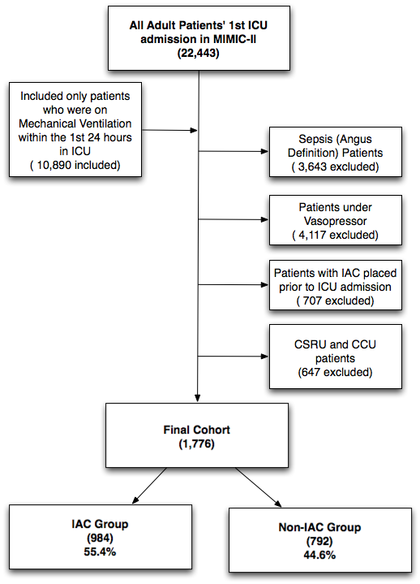

Figure 2: Propensity score distribution plot comparing the IAC and non-IAC groups before and after matching.

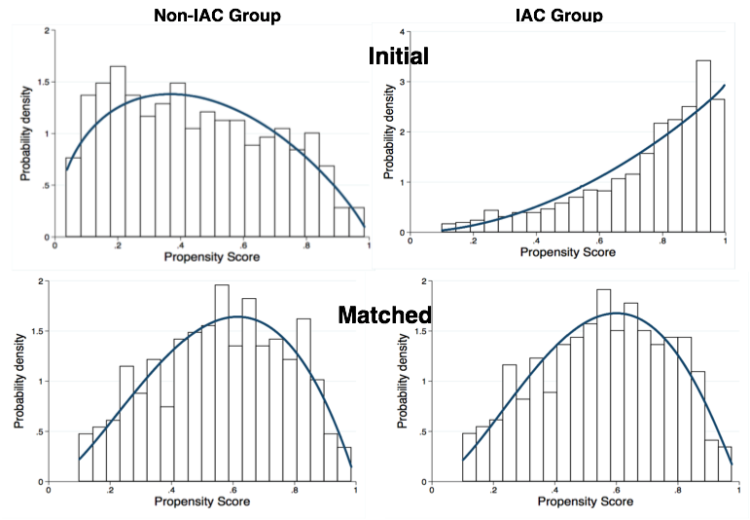

Table 1. Baseline covariates between IAC and non-IAC groups in unmatched cohorts and propensity-matched cohorts

|  |  |  |  |  |  |  |
| --- | --- | --- | --- | --- | --- | --- |
|  | **Entire Cohort (1776)** | | | **Matched Cohort (696)** | | |
| **Variables** | **Non-IAC (n=984)** | **IAC (n=792)** | **p-value** | **Non-IAC (n=348)** | **IAC (n=348)** | **p-value** |
| Age (yr.) | 51 (35-72) | 56 (40-73) | 0.009 | 53 (35-72) | 54 (38-73) | 0.4 |
| Female | 344 (43.5%) | 406 (41.3%) | 0.36 | 205 (58.9%) | 192 (55.2%) | 0.36 |
| SOFA Score | 5 (4-6) | 6 (5-8) | <0.0001 | 5 (4-7) | 6 (4-7) | 0.6 |
| **Service Unit** |  |  | <0.0001 |  |  | 0.6 |
| MICU | 504 (63.6%) | 290 (29.5%) | 184 (52.9%) | 192 (55.2%) |
| SICU | 288 (26.4%) | 694 (70.5) | 164 (47.1%) | 156 (44.8%) |
| **Co-incident Diseases** |  |  |  |  |  |  |
| Chronic obstructive pulmonary disease | 81 (10.23%) | 76 (7.72%) | 0.07 | 32 (9.2%) | 39 (11.2%) | 0.5 |
| Respiratory disease(non-COPD)1 | 278 (35.1%) | 287 (29.2%) | 0.008 | 121 (34.7%) | 125 (35.9%) | 0.8 |
| Pneumonia | 147 (18.6%) | 152 (15.5%) | **0.005** | 67 (20%) | 68 (20.3%) | 1 |
| Congestive Heart Failure | 97 (12.5%) | 116 (11.8%) | 0.7 | 44 (12.6%) | 36 (10.3%) | 0.4 |
| Atrial Fibrillation | 82 (10.4%) | 125 (12.7%) | 0.1 | 36 (10.3%) | 32 (9.2%) | 0.7 |
| Chronic kidney disease | 28 (3.5%) | 32 (3.3%) | 0.8 | 13 (3.8%) | 10 (2.9%) | 0.7 |
| Liver Disease | 28 (4.8%) | 61 (6.2%) | 0.2 | 14 (4%) | 18 (5.2%) | 0.6 |
| Coronary artery disease | 51 (6.4%) | 72 (7.32%) | 0.5 | 23 (6.6%) | 21 (6%) | 0.8 |
| Stroke | 70 (8.8%) | 152 (15.5%) | 0.0001 | 32 (9.2%) | 33 (9.5%) | 1 |
| Malignancy | 92 (11.6%) | 164 (16.7%) | 0.003 | 44 (12.6%) | 51 (14.7%) | 0.6 |
|  |  |  |  |  |  |  |
|  |  |  |  |  |  |  |
| **Laboratory Tests** |  |  |  |  |  |  |
| WBC | 10.6 (7.8-14.3) | 11.8 (8.5-15.9) | **<0.0001** | 10.7 (8-14.8) | 11.5 (8.4-14.7) | 0.3 |
| Hemoglobin | 13 (11.3-14.4) | 12.6 (11-14.1) | **0.003** | 12.8 (11.2 -14.2) | 12.7 (11-14.1) | 0.5 |
| Platelet | 246 (190-304) | 237 (177-294) | 0.01 | 238 (184-303) | 238 (186-289) | 0.7 |
| Sodium | 140 (138-143) | 140 (137-142) | 0.007 | 140 (138-143) | 140 (137-142) | 0.6 |
| Potassium | 4 (3.6-4.5) | 4 (3.7-4.4) | 0.77 | 4 (3.6-4.5) | 4 (3.7-4.4) | 0.8 |
| Bicarbonate | 24 (22-27) | 24 (21-27) | 0.05 | 24 (22-27) | 24 (21-27) | 0.6 |
| Chloride | 104 (100~107) | 104 (101~108) | **0.0003** | 104 (100~107) | 104 (100~107) | 1 |
| BUN | 15 (11~21) | 16 (12~22) | **0.02** | 15 (11~22) | 16 (12~22) | 0.3 |
| Creatinine | 0.9 (0.7~1.1) | 0.9 (0.7~1.1) | 0.6 | 0.9 (0.7~1.2) | 0.9 (0.7~1.1) | 0.07 |
| PaO2 | 206 (96~375) | 200 (108~337) | 0.5 | 180 (104~340) | 187 (106~300) | 0.7 |
| PaCO2 | 42 (37~50) | 41 (36~48) | **0.02** | 41.5 (37~47) | 40 (35~46.5) | 0.2 |
|  |  |  |  |  |  |  |
| DNR at Admission | 65 (8.2%) | 39 (4%) | **<0.0001** | 20 (5.8%) | 12 (3.5%) | 0.2 |
| Switched to DNR and CMO | 41 (5.2%) | 95 (9.7%) | **<0.0001** | 35 (10.4%) | 34 (10.1%) | 1 |

1 ICD-9-CM code 518*, which includes acute respiratory distress syndrome (ARDS).

Table 2: Primary and secondary outcomes for propensity-matched IAC and non-IAC groups

|  |  |  |  |  |
| --- | --- | --- | --- | --- |
| **Primary Outcome** | **Non-IAC** | **IAC** | **p-value** | **Odds Ratio**  **(95% CI)** |
| 28 day mortality | 15.20% | 14.70% | 0.9 | 0.95 (0.62, 1.46) |
|  | | | | |
| **Secondary Outcomes** | **Non-IAC** | **IAC** | **p-value** | **Mean Difference**  **(95% CI)** |
| ICU LOS (survivors) | 2.2 (1.4)1 | 3.7 (3.1) | <0.0001 | -0.66 (-0.82, -0.5) |
| ICU LOS (non-survivors) | 3.6 (2.2) | 6.2 (5.3) | 0.006 | -0.33 (-0.88, 0.22) |
| Hospital LOS (survivors) | 5.7 (4.8) | 9.4 (7.5) | <0.0001 | -0.57 (-0.74, -0.41) |
| Hospital LOS (non-survivors) | 5.4 (4.5) | 7.6 (7) | 0.003 | -0.37 (-0.82, 0.07) |
| Mechanical ventilation time (survivors) | 1 (1) | 2.1 (2.6) | <0.0001 | -0.54 (-0.7, -0.38) |
| Mechanical ventilation time (non-survivors) | 2 (1.6) | 5.3 (5.3) | 0.0003 | -0.78 (-1.36, -0.2) |
| Arterial blood gas measurements (per 24 hours) | 1 (0.8) | 2.4 (1.4) | <0.0001 | -1.28 (-1.44, -1.11) |

1 All continuous variables reported as mean with standard deviation range

Figure 3. Sensitivity analyses using various propensity score models and matching caliper levels. The findings from sensitivity studies were consistent with the original study design. As shown in (a), the Odds Ratio for IAC placement and 28-day mortality are around 1.0 (highlighted with a red line). In addition, as shown in (b), the p values for all the analyses were statistically insignificant (p>0.05).

